File Structures

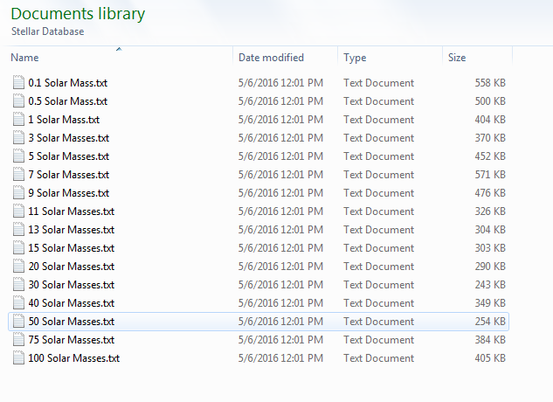

This project was very data intensive. It involves the use of numerous text files, which were sent via email from the website EZ-Web. Each data file contains around 900 data points, and each data point gives data for 29 quantities (We only use 14 of those). All of the text files are found in a folder found within the folder with the code itself, allowing for easy organization and access.